Embedded Systems Assessment Tool 3

Question
Construct a program comparing polling-based delay and interrupt-based timing in Embedded C.

Aim
To compare polling-based delay and hardware interrupt-based timing using an Arduino Uno.

Algorithm
1. Start the program and initialize LEDs, push button, and serial communication.
2. Configure D12 as polling LED and D13 as interrupt LED.
3. Configure D2 as interrupt input using attachInterrupt().
4. Blink the polling LED and periodically check the button state.
5. If the polling detects the button press, display a polling message.
6. If the hardware interrupt occurs, execute the ISR, set the interrupt flag, and blink the interrupt LED.
7. Repeat continuously.

Analysis
Polling continuously checks the button status, so the CPU spends time repeatedly reading the input. Hardware interrupts allow the processor to execute other tasks until the button generates an interrupt on pin D2. The Interrupt Service Routine (ISR) executes immediately, demonstrating faster response and better CPU utilization than polling.

Embedded C Program
const int pollingLED = 12;
const int interruptLED = 13;
const int buttonPin = 2;
volatile bool interruptFlag = false;
void buttonISR() {
interruptFlag = true;
}
void setup() {
pinMode(pollingLED, OUTPUT);
pinMode(interruptLED, OUTPUT);
pinMode(buttonPin, INPUT_PULLUP);
attachInterrupt(digitalPinToInterrupt(buttonPin), buttonISR, FALLING);
Serial.begin(9600);
}
void loop() {
digitalWrite(pollingLED, HIGH);
delay(500);
if (digitalRead(buttonPin) == LOW) {
Serial.println("Polling: Button Detected");
}
digitalWrite(pollingLED, LOW);
delay(500);
if (interruptFlag) {
interruptFlag = false;
digitalWrite(interruptLED, HIGH);
Serial.println("Interrupt Triggered!");
delay(300);
digitalWrite(interruptLED, LOW);
}
}

Expected Output
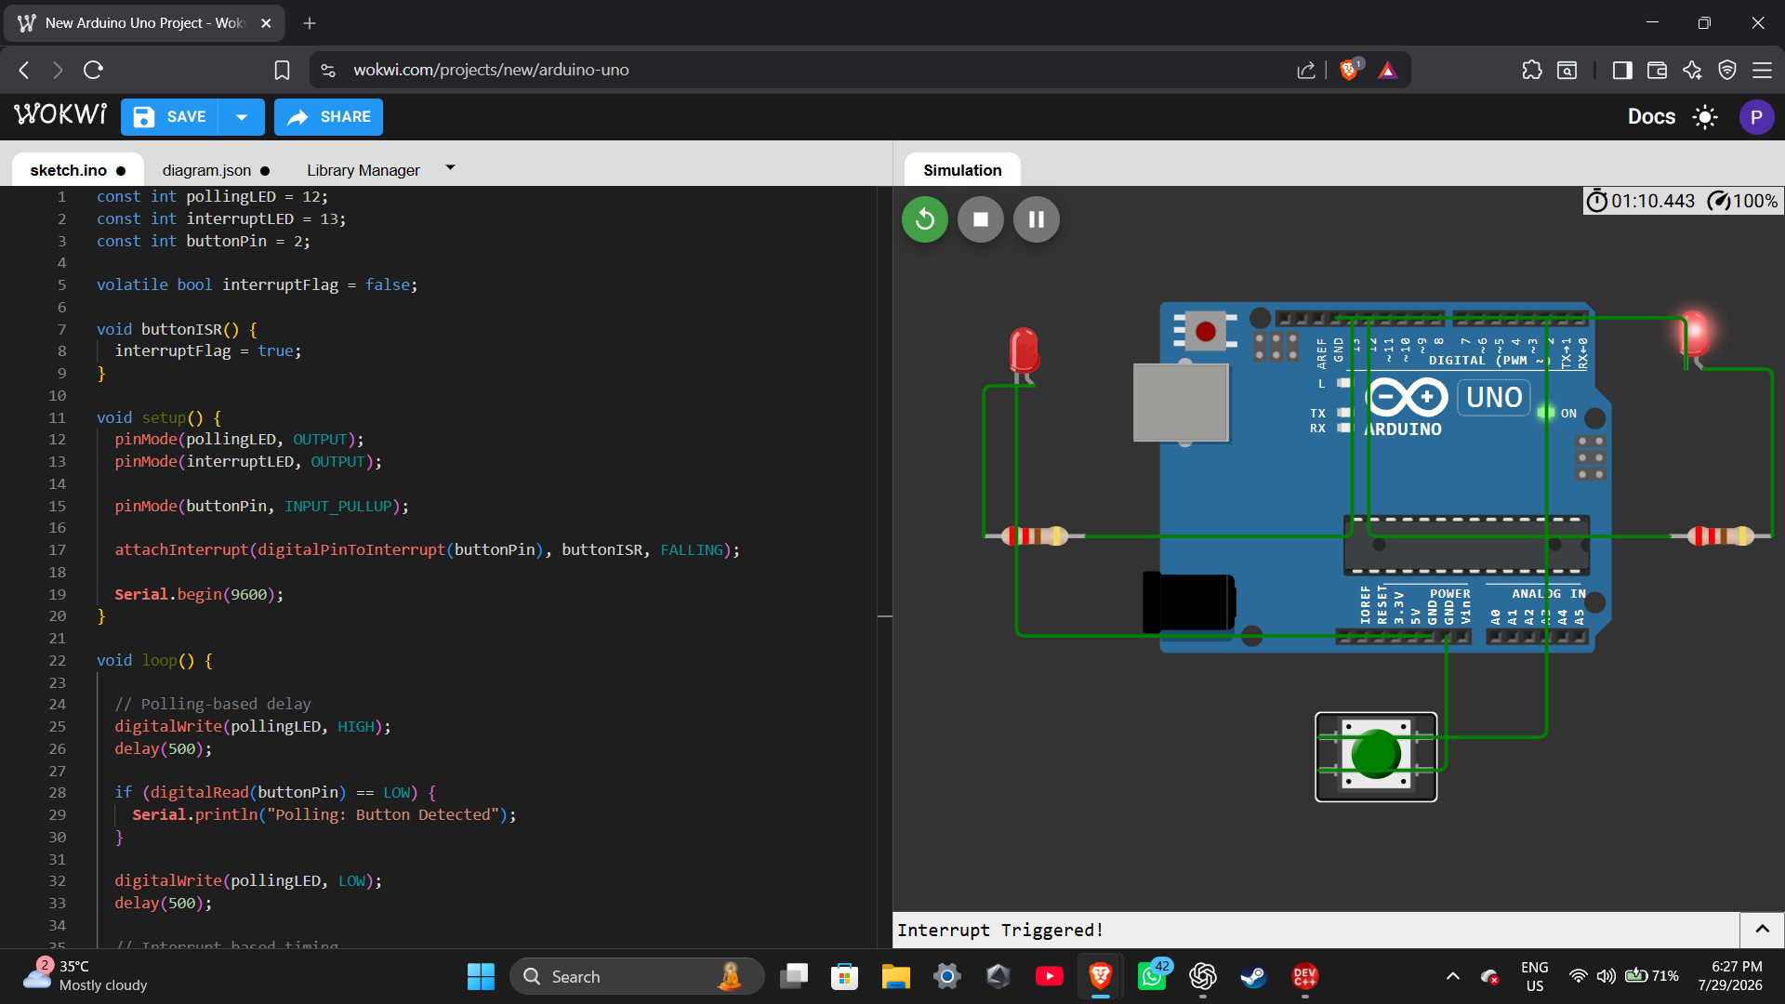

Result
The program successfully demonstrates the difference between polling-based delay and hardware interrupt-based timing. Polling continuously checks the button state, whereas the interrupt responds immediately when the button is pressed, resulting in faster response and improved CPU efficiency.

